# Proof of Concept

## Overview

In this proof of concept (PoC) you will take an existing legacy .NET application (explained below) and “containerize” it. This approach is commonly known as lift and shift as you are not required to make any design changes to the existing application. The following sections describe the existing application design and approach you may want to take to containerize it.

Please do keep in mind that there are multiple ways to containerize the existing application. The goal is to try to containerize it yourself without any assistance based on knowledge gained during the education sessions. You can work with a partner/group or work on your own, it’s up to you!

## Problem Statement

You are a developer consultant helping the Kent County Public School District to containerize their history teaching application. They want to use containers because developers are always arguing over the application “working just fine on my machine” when changes are pushed, however the application is constantly breaking on different environments. Also, the method for deploying each application to production is different, and they want a nice way to streamline deploying all their various apps.

The application displays historical events that were saved in the database based on a certain time-period in history (Renaissance, French Revolution, WWI, and WWII). There is one .NET web app solution with an associated SQL database for its data. They also hand you a Database folder that has a “import-json-files-to-tables” so you can import their data and connect to it with the application. The Database folder also holds a JSON file with the frenchrevolution, renaissance, wwi, and ww2 content.

Prerequisite Software (all already installed on lab VM)

1. Visual Studio 2017
2. Windows Container support
3. Docker Engine and Docker CLI
4. Microsoft SQL Server 17 Management Studio
5. Microsoft SQL Server 2017 SP1 Express

Tasks:

1. Test out that your application works locally with the database first, you should always make sure the application works locally before throwing it into a container. Get the database working with the data. Get the application connected to the local database with their data. Steps to restore the database will be provided below under the section titled “Legacy Application Setup & Walkthrough”.

1. In the containerization phase, you need to create two Dockerfiles: One for ASP.NET web application and other for the SQL server. You can ask instructor(s) for assistance while doing through the process of creating these files.
   1. Note: The School District would like you to use this base image for their web app: **microsoft/iis** and this base image for their SQL database: **microsoft/mssql-server-windows-express**. They would like you to utilize Dockerfiles (one for their web app, one for their database).
   2. The application files are in your Windows LOD VM under **C:\PoC**
2. Create a docker-compose.yml file that will run both of your Dockerfiles. If you did it correctly, you should be able to run the docker-compose.exe up command and see the application working with the database!

Legacy Application Setup & Walkthrough

Restore Database:

First, you need to restore the application database provided to you. The name of database file is “HistoricEvents.bak”. Please follow the steps below to restore the database.

1. Open SQL Server Management Studio, it is pinned to your taskbar:



1. Click Server Name and select ‘<Browse for more… >’

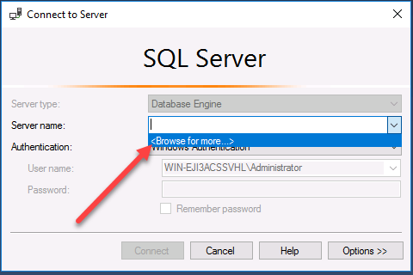

1. Click the “+” sign under Database Engine and choose the only option there, then hit OK.

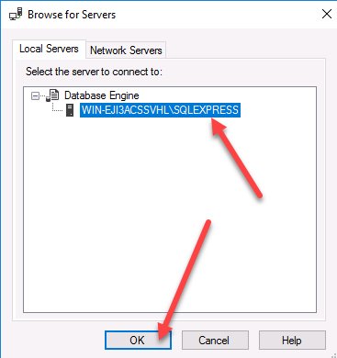

1. Choose Windows Authentication and then hit Connect:

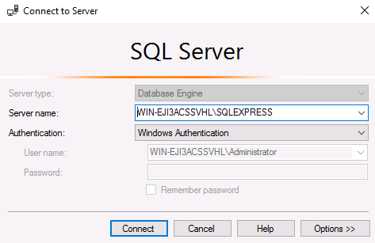

1. From the Object Explorer right click the “Databases” and select “Restore Database”.

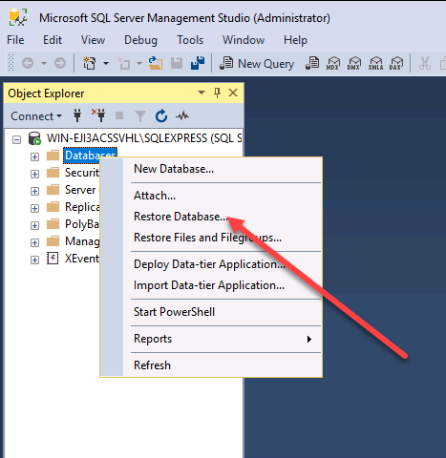

1. On the “Restore Database” window select the “Device” option and then press “…” button next to it.

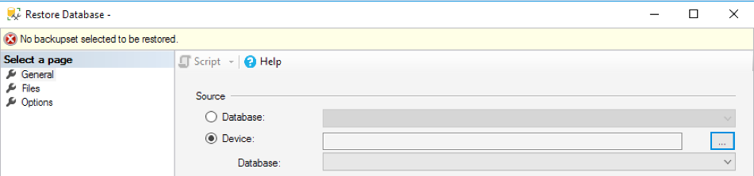

1. On the Select backup devices option press “Add” and then select “HistoricEvents.bak” file that is provided to you. Finally press “OK”.

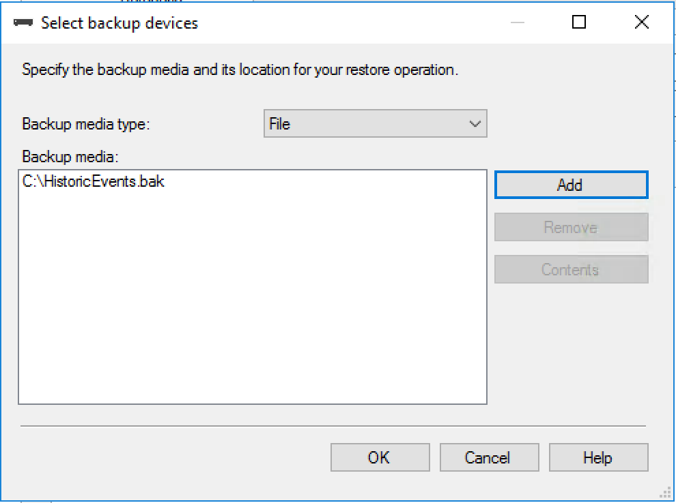

1. Press “OK” on the Restore Database window.

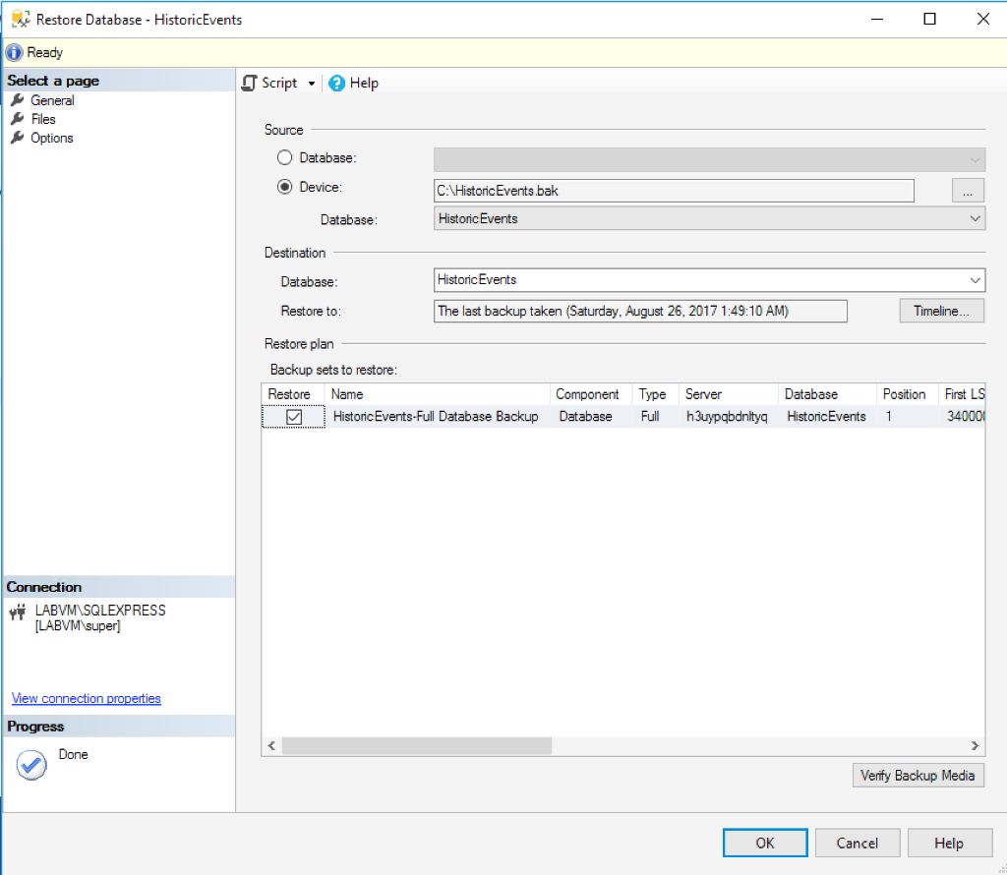

1. You should see a “Database ‘HistoricEvents’ has restored successfully” message. Press “OK” to close the window.
2. From the Object Explorer expand the “Historic Events” database and then further expand the “Tables”. You should see custom database tables.

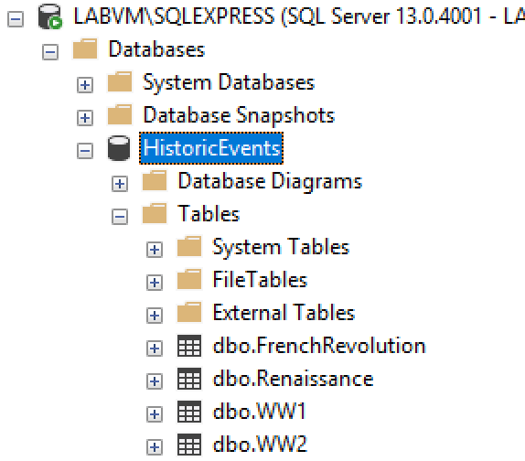

1. You have now successfully resorted the database. You may want to keep the SQL Server Management Studio open for later use.
2. The application files are in your Windows LOD VM under **C:\PoC**, go to this location and open the .sln file in Visual Studio.
3. Find the Web.config file and edit the Connection String so that it will connect to your local database. Test out the application locally.
4. Good luck containerizing the application! Don’t forget to use the base images they requested to make the Dockerfiles, and to make sure you do a docker-compose.yml file for them.